Crowdfunding Platform Powered by Blockchain

Prof. Ravi Ray Chaudhari Department of Computer Engineering *SKNSITS*

Lonavala, Pune.

[raviray.sknsits@sinhgad.edu](mailto:raviray.sknsits@sinhgad.edu)

Prafulla B. Dhobale

Department of Computer Engineering

*SKNSITS*

Lonavala, Pune.

[prafulladhobale.sknsits.comp@gmail.com](mailto:Prafulladhobale.sknsits.comp@gmail.com)

Abhijit V. Raut

Department of Computer Engineering

*SKNSITS*

Lonavala, Pune.

[abhijitraut.sknsits.comp@gmail.com](mailto:abhijitraut.sknsits.comp@gmail.com)

Aniket A. Sinare

Department of Computer Engineering SKNSITS

*Lonavala, Pune*

[aniketsinare.sknsits.comp@gmail.com](mailto:aniketsinare.sknsits.comp@gmail.com)

Prathamesh R. Sawant

Department of Computer Engineering

*SKNSITS*

*Lonavala, Pune*

[prathameshsawant.sknsits.comp@gmail.com](mailto:prathameshsawant.sknsits.comp@gmail.com)

*Abstract*—**In the situation of the Covid-19 plague, many organizations are raising funds to help local governments to obtain additional sources of funds that will be distributed to those in need. Trust is an important factor for the parties involved in raising these funds, both in terms of the funder, the service provider of fundraising platform and even the fundraiser. On this occasion, the author tries to analyze how to implement blockchain technology and smart contracts in the dominant schemes of crowdfunding process. the results of this study indicate that blockchain-based smart contracts can be applied to the dominant schemes of crowdfunding process.**

***Keywords—***:Cyber-insurance,Blockchain, Crowdfunding, Sealed-bid auction.

1. INTRODUCTION

In this industrial era 4.0, almost all industrial sectors apply technology to support their business, from businesses that are for-profit to businesses that are non-profit. Non-profit organizations (non-profit) have characteristics that are almost the same as profit-oriented organizations (profit) profit-oriented, but between these two organizations have different problems. In the current situation of the Covid-19 plague, almost every country has the same problem in dealing with this problem, especially in terms of the funds needed. Many strategies carried out by the government how to manage government funds in tackling this Covid-19 plague outbreak. This situation also triggered the community to raise funds to help the government in tackling this Covid-19 plague outbreak. In the process of raising funds, of course it is not easy, because it requires trust between many parties, both the funders, intermediaries or organizations as a place to store temporary funds to the recipient of funds. That trust is the main capital for fundraising organizations to attract funders to donate their funds to recipients of funds. Lots of non-profit organizations play a role as fundraisers, especially in the condition of the Covid-19 plague. Trust is their challenge in attracting donors to donate their money to the organization. Not a few also a non-profit organization that uses technology to make it easy for donors to donate funds through them. So from this it can be concluded that in addition to trust which is the main factor to get as many funds as possible, technology also plays a big role in this as well input and control from humans

1. LITERATURE REVIEW

Alexandra Moritz and Joern Hendrich Block in their paper [1] titled “Crowdfunding: A Literature Review and Research Directions” proposed that the scientific object on crowdfunding were recognize in the first time in a Google Scholar title keyword search for the word “crowdfunding” & “crowd investing”. The next step is, the search was proceeded with based on the mention of cited in the object. Later, such as peer-to-peer online, specific object, P2P lending, social lending and person-to-person added were investigated.[1] Alexandra Moritz and Joern Hendrich Block in their paper [1] titled “Crowdfunding: A Literature Review and Research Directions” proposed that the scientific object on crowdfunding were recognize in the first time in a Google Scholar title keyword search for the word “crowdfunding” & “crowd investing”. The next step is, the search was proceeded with based on the mention of cited in the object. Later, such as peer-to-peer online, specific object, P2P lending, social lending and person-to-person added were investigated.[1]

and student. The format of feedback varies from establishment to establishment, thus there cannot be a general technique which will appropriate all. The feedback information from the scholars is analyzed by victimization completely different data processing techniques. Agrawal, Ajay K, Catalini Christian & Goldfar Avi in their paper [3] titled “The geography of crowd funding” proposed that they build their results in three steps. First, they document that investors’ tendency to invest in a week raises as the entrepreneur visibly conceal capital on the site. Next, they show that venture capitalist does not follow this structure. Rather, they are most likely to invest early in phase, before an entrepreneur has raised $10,000. Finally, they show that this difference between remote and local investors is entirely explained by the group of investors they labelled Friends and Family (F&F). The results were so robust to multiple specifications, some of which appear in the paper and some in the appendix.[3]

Lingfei Deng, Qiang Ye, DaPeng Xu, Wenjun Sun & Guangxin Jiang in their paper [4] titled “A literature review and integrated framework for the determinants of crowdfunding success” proposed that Given the reputation of crowdfunding platforms among the small entrepreneurs, it is essential to complete understand the determinants of crowdfunding success to promote capital resource allocation ability.

Can be enforced both legally in the enforcement of rights and the implementation or execution through computer code that cannot be changed or approved. Smart Contract can be deployed on top of blockchain technology to automate complex transaction. The Smart Contract is a code that can be executed and executed on a blockchain platform that is used to facilitate, execute and enforce the terms of a contract or agreement. The main purpose of the Smart Contract is to fulfill the agreement after the terms of a contract have been fulfilled.

1. METHODOLOGY

* A literature study is another term for literature study, literature review, theoretical study, theoretical foundation, literature review, and theoretical review. What is meant by library research is research conducted only based on written works, including research results both those that have been and that have not been published.

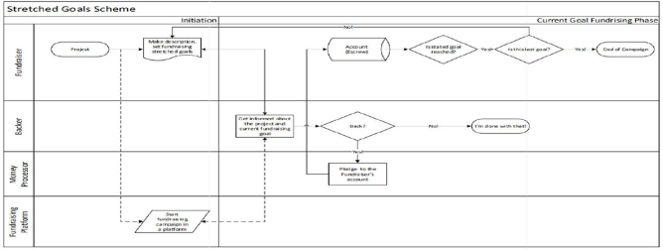

Fig1.Workflow

* Before submitting a proposal to a fundrising platform, of course fundraisers must register to a fundraising platform service providers. of course, each service provider has its own rules who can submit proposals to find funds in their organizations. In general, the fundraiser registration process only involves two entities, the fundraiser and the service provider of fundraising platform itself.
* Similar to the fundraising registration process, donors certainly need to register with a fundraising platform service provider, both offline and online. This is needed so that fundraising knows the source of funds provided for fundraising. Data from this fundraising course is also stored in the fundraising database and can only be accessed by parties who have been determined by the service provider. This process also involves 2 entities, namely the funder and the fundraising platform service provider. all historical transactions are stored in a system provided by the fundraising platform service provider.
* To raise funds, a fundraiser must submit a proposal to the fundraising organization. each fundraising organization certainly has its own rules for publishing proposals from fundraisers. Every proposal that enters the fundraising organization certainly goes through a very strict verification using smart contract and blockchain technology.

1. EXPERIMENTAL RESULTS

Registration - Fundraiser Before submitting a proposal to a fundrising platform, of course fundraisers must register to a fundraising platform service providers. of course, each service provider has its own rules who can submit proposals to find funds in their organizations. In general, the fundraiser registration process only involves two entities, the fundraiser and the service provider of fundraising platform itself. The fundraiser will register to service provider of fundraising platform. In this case, the data from the fundraiser is stored in the service provider database and can be accessed by certain parties in accordance with the rules that apply to the service provider of fundraising platform. All transaction or historical data of fundraiser only can be consumed by service provider. [2]. Registration – Funder ( Backer ) Similar to the fundraising registration process, donors certainly need to register with a fundraising platform service provider, both offline and online. This is needed so that fundraising knows the source of funds provided for fundraising. Data from this fundraising course is also stored in the fundraising database and can only be accessed by parties who have been determined by the service provider. This process also involves 2 entities, namely the funder and the fundraising platform service provider. all historical transactions are stored in a system provided by the fundraising platform service provider. 3. Fundraising Campaign To raise funds, a fundraiser must submit a proposal to the fundraising organization. each fundraising organization certainly has its own rules for publishing proposals from fundraisers. Every proposal that enters the fundraising organization certainly goes through a very strict verification using smart contract and blockchain technology. Things that can be applied to this process are the process of verifying data from seekers and funders, eliminating dependency with third parties (banks) and shortening the submission and disbursement of funds. whereby the fundraising does not reach the target with a certain amount and time then the funds collected will be returned to the fundraiser either directly or indirectly and there is also the possibility to develop the fundraising with certain term and conditions. In this case, block chain technology can be used, so that data that enters the fundraising database can be trusted. Based on the block chain category, the appropriate category is applied to the fundraising process, according to the authors, the blockchain can be applied is categorized as a consortium, where only certain and KIA schemes, where there is a possibility of a refund, with blockchain technology all transactional historical data carried out between related parties is stored securely and cannot be changed so that from here it can be used as a reference for direct refunds to funders . Whereas in the SGS scheme, where the fundraising can be developed with the terms and conditions that have been determined, with this blockchain technology can be tracked from the beginning of this fundraising activity to the final destination of the fundraising.

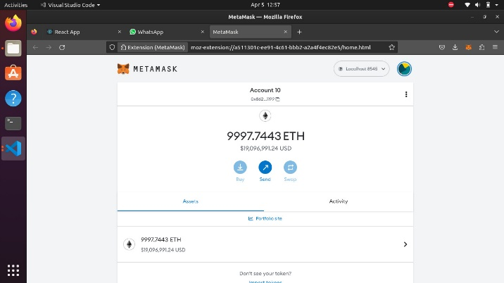

1. REAL-TIME WORKING

|  |  |
| --- | --- |
| **Algorithm Used** | **Accuracy Obtained** |
| Naïve Bayes | 50 |
| Support Vector Machine | 60.8 |
| Artificial Neural Network | 88.2 |

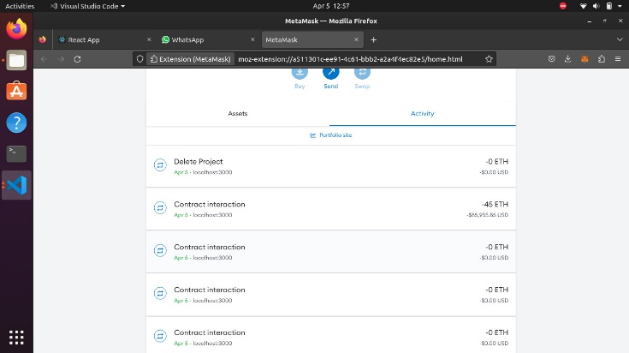

Fig.6 fund

1. WORKFLOW

Fig. 8 Output.

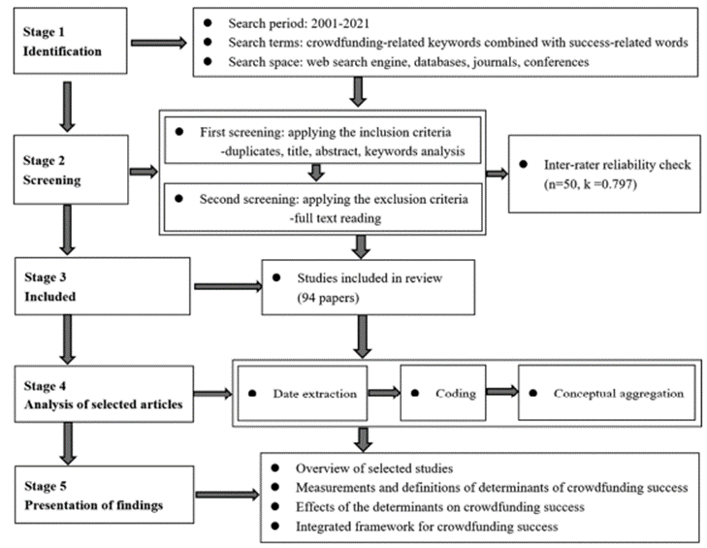

Fig. 5 Activity

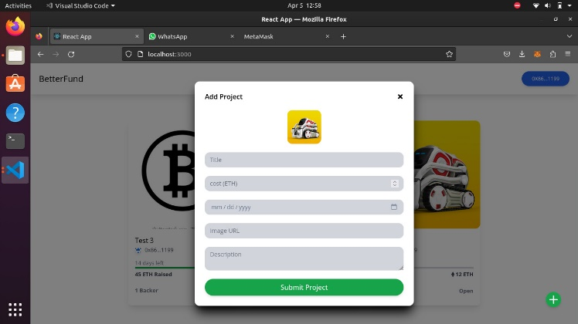

Fig.6 :Add project

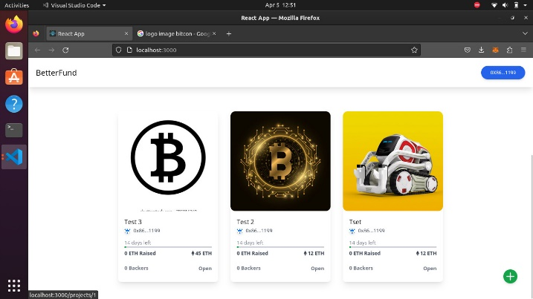

Fig.7 GUI

Fig. 9 Model Workflow.

1. CONCLUSION AND FUTURE WORK

The market size of crowdfunding worldwide is expected to grow with a rate of 15.9% between 2018-25. While the market value of the same in India is estimated to grow at 0.81% rate between 2020-24. The usage of internet increases especially for the mobile user: Crowdfunding typically takes place throught the internet. Social media entrance among the social media users. The continuously like and share on social media platforms supports one raise funds by imminence after one’s own network. However, due to lack of regulatory stance and trust on online fundraising, Indian crowdfunding segment witnessed a decline in their growth.

Crowd funding is an application which provides source of crowd. It is extensively moving in great extent in an upward direction of raising funds for individuals and ventures for student education. The overseas nations have already started implementation of crowd funding regulatory frameworks using latest technology stake like blockchain. In India this concept must be to further the development of more so that a blooming industry grows fast. Crowdfunding represents a unique way for founders to raise capital for a wide variety of projects. Due to its fast rise, the dynamics of crowdfunding have been largely unstudied. This paper offers some probing insights into how crowdfunding works. Projects generally succeed by small margins or fail by large ones.

Conventional crowdfunding methods have long suffered from lack of transparency and fraud. The aim to have a transparent, anti-fraudulent, decentralized platform has been achieved to a great extent. This paper has covered the weak points of general crowdfunding platforms to provide transparency to the process of crowdfunding and build trust among people, so that they may contribute their wealth to good causes without fear of fraud.

REFERENCES

* 1. Alexandra Moritz and Joern Hendrich Block – “Crowdfunding: A Literature Review and Research Directions”, Trier University, Trier, Germany Erasmus University Rotterdam, Rotterdam, Netherlands.
  2. Abhrajit Sarkar – “Crowd Funding In India: Issues & Challenges”, Research Scholar JIS University.
  3. Agrawal, Ajay K, Catalini Christian & Goldfar Avi – “The geography of crowd funding” Technical Report, National Bureau of Economics Research 2011.

lgorithm”International Journal of Engineering Science and Computing, June 2017.

* 1. Pang, B. and Lillian L. s.l, “Opinion mining and sentiment analysis: Foundations and trends in information retrieval”, Vol. 2, 2016
  2. Trisha Patel, “Sentiment Analysis of Parents Feedback for Educational Institutes”, International Journal of Innovative and Emerging Research in Engineering, Volume 2, Issue 3, 2017.
  3. S. Katragadda, V. Ravi, P. Kumar, and G. J. Lakshmi, "Performance Analysis on Student Feedback using Machine Learning Algorithms," 2020 6th International Conference on Advanced Computing and Communication Systems (ICACCS), 2020, pp. 1161-1163, DOI: 10.1109/ICACCS48705.2020.9074334
  4. Kajal et al. (2017), “Opinion Mining: Aspect level sentiment analysis using sentiwordNet and Amazon Web Services”, International Journal of Computer Applications, Volume 158- No 6, January 2017.
  5. Esuli, A. and Sebastiani, F. (2006), “SentiWordNet: A publicly available lexical resource for opinion mining” In Proceedings of LREC, Vol. 6, pp. 417-422.
  6. Jain, V. K., & Kumar, S. (2016), “Improving Customer Experience Using Sentiment Analysis in E-Commerce”, Handbook of Research.
  7. Anam Amjad and Usman Qamar. 2019. UAMSA: Unified Approach for Multilingual Sentiment Analysis Using GATE. In Proceedings of the 6th Conference on the Engineering of Computer Based Systems (ECBS '19). Association for Computing Machinery, New York, NY, USA, Article 25, 1–5.
  8. Harshit Sanwal, Sanjana Kukreja, 2019, Design Approach for Opinion Mining in Hotel Review using SVM With Particle Swarm Optimization (PSO), INTERNATIONAL JOURNAL OF ENGINEERING RESEARCH & TECHNOLOGY (IJERT) Volume 08, Issue 09 (September 2019)